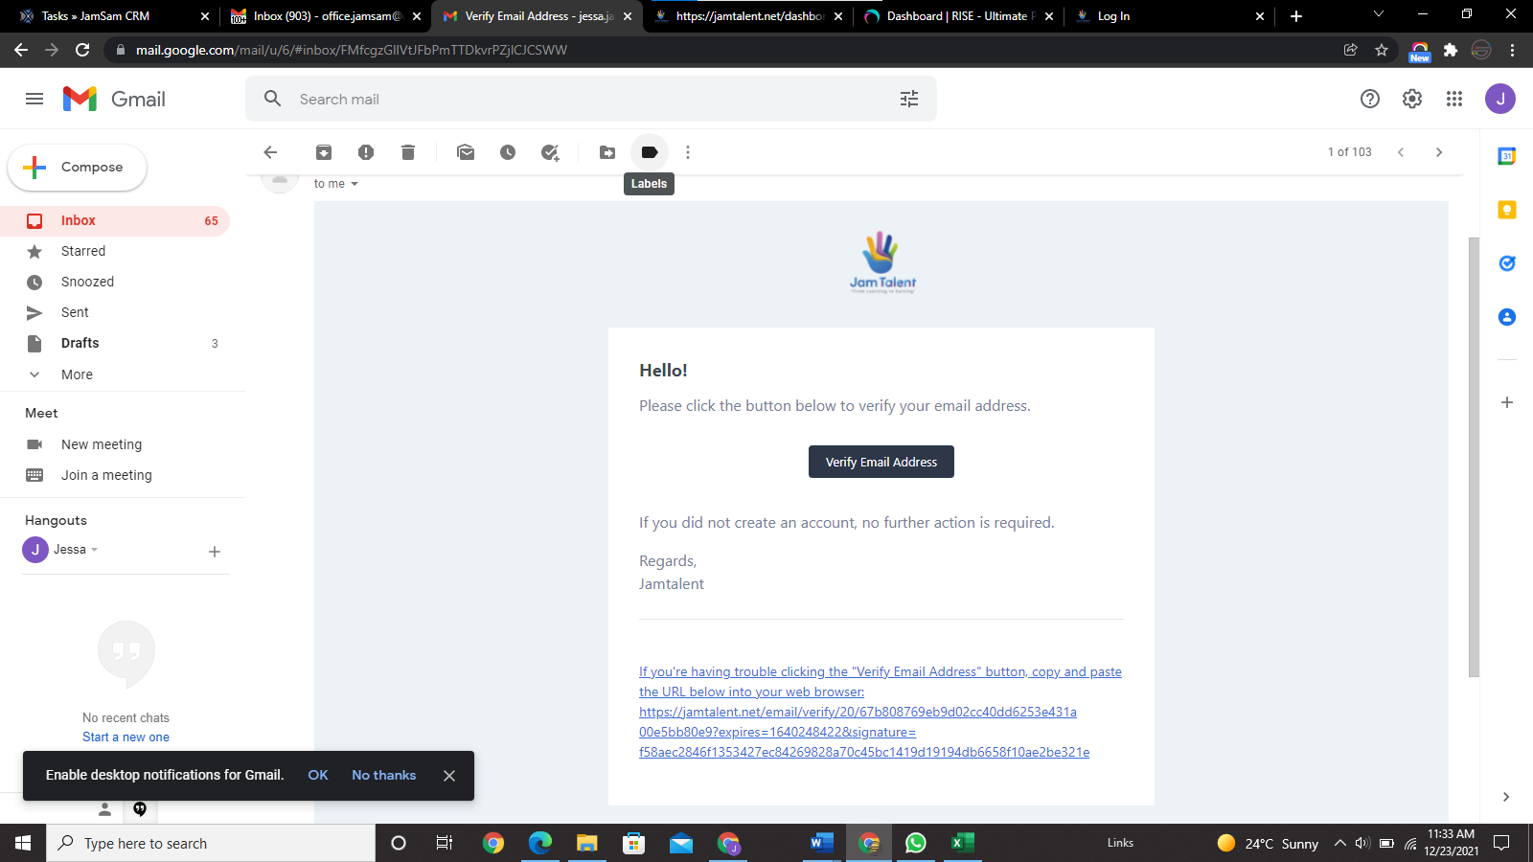 welcome note?

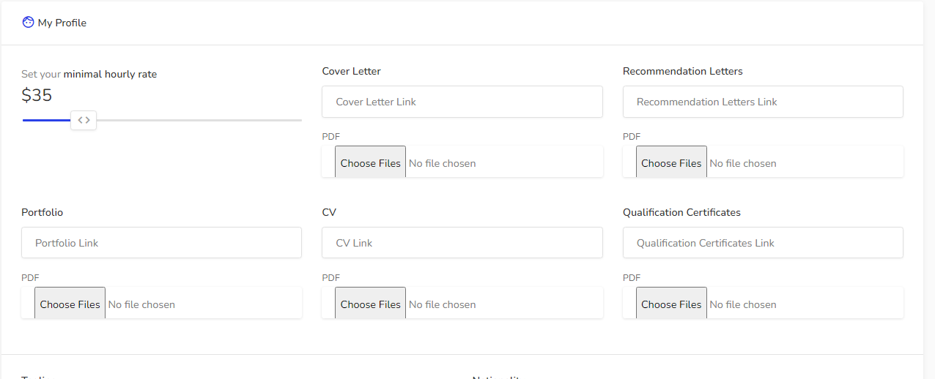 This part does not look good

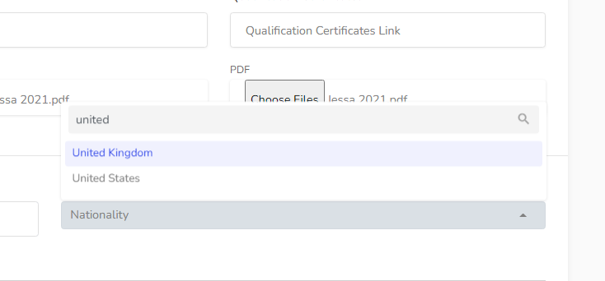United Arab Emirates not UAE

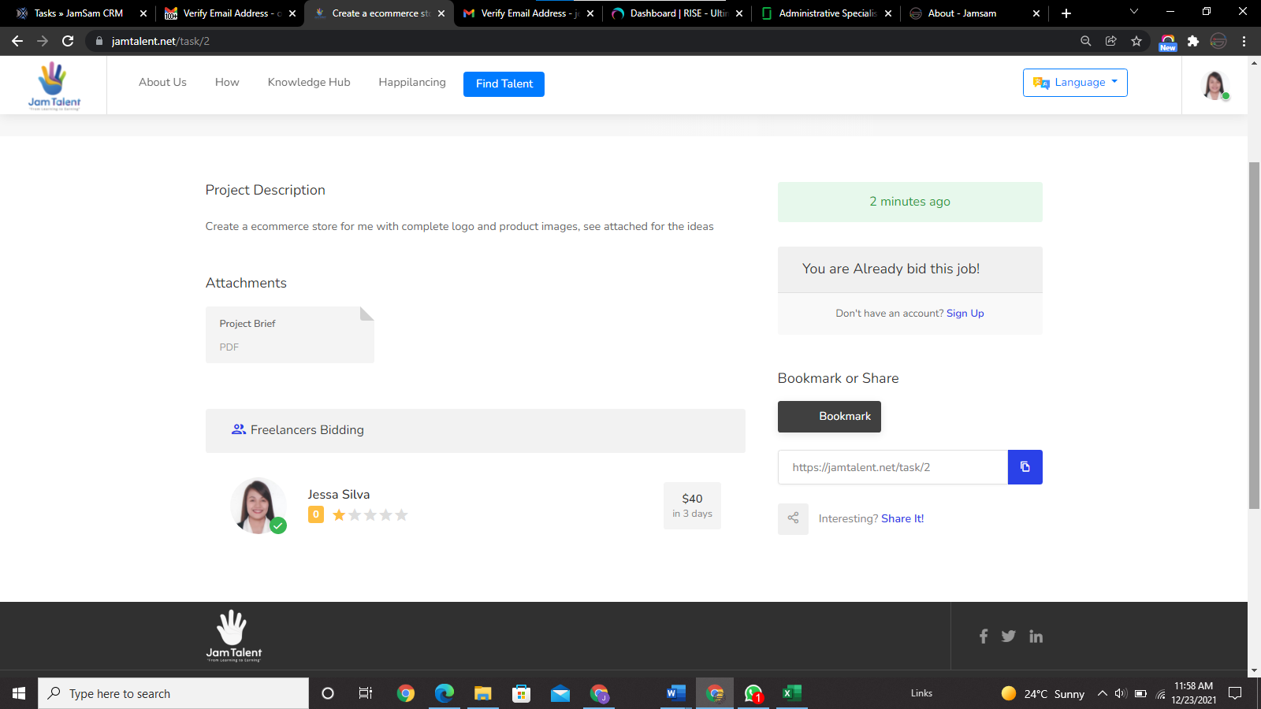 shows I bid already for the task, but I did not bid yet.

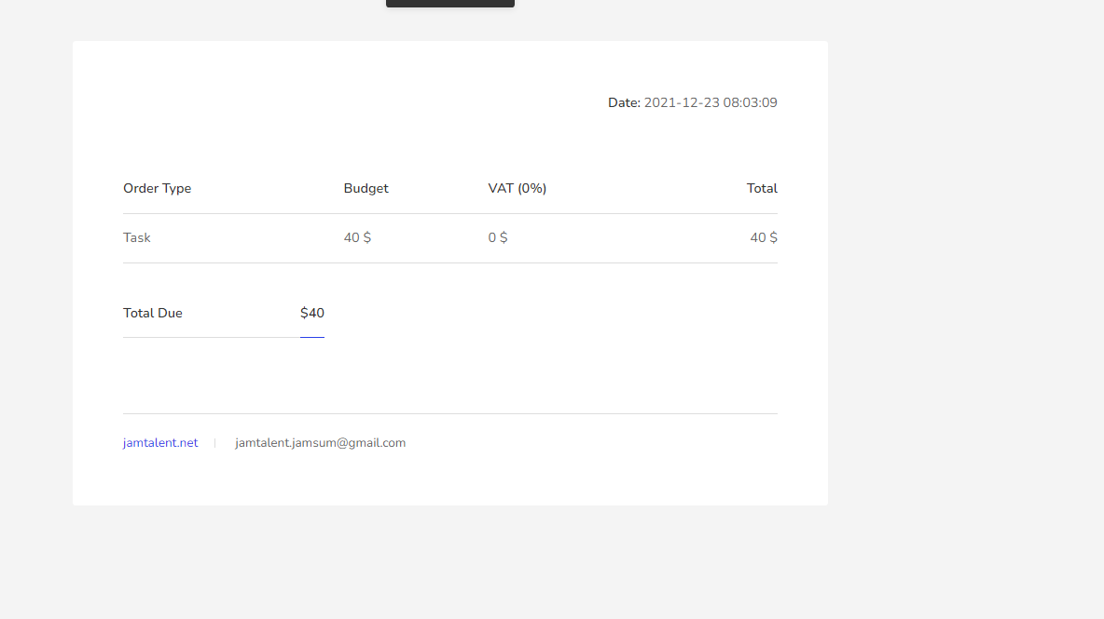 I would suggest to put name of the employer and freelancer to have a better look of an invoice, also spelling of jamsam is jamsum here.

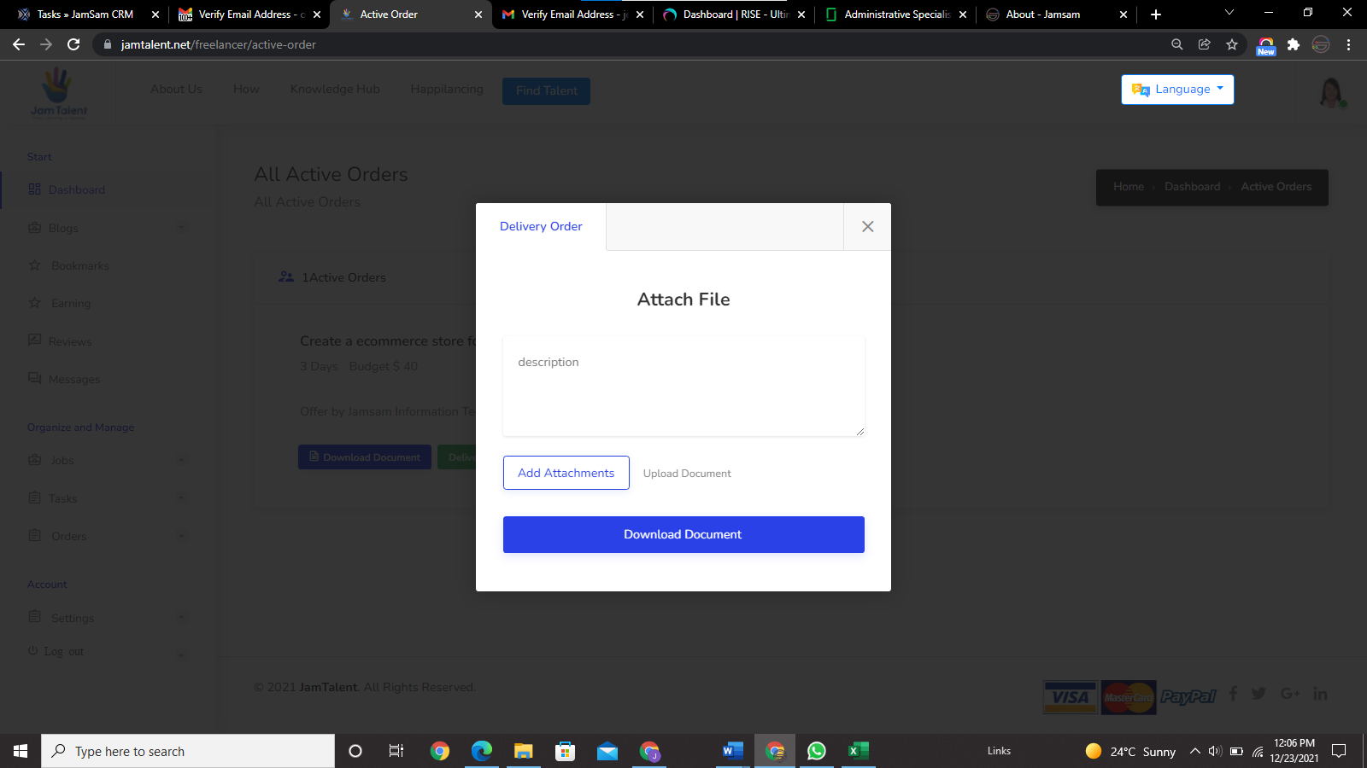 Capital letter D, for Document

Also download? Or upload document?

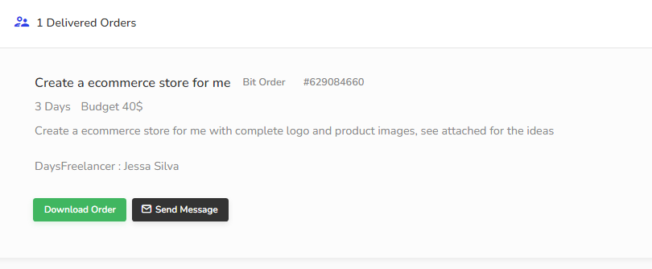 label each description

For example

Task: Create ecommerce store for me with complete logo and product images

What is daysfreelancer???

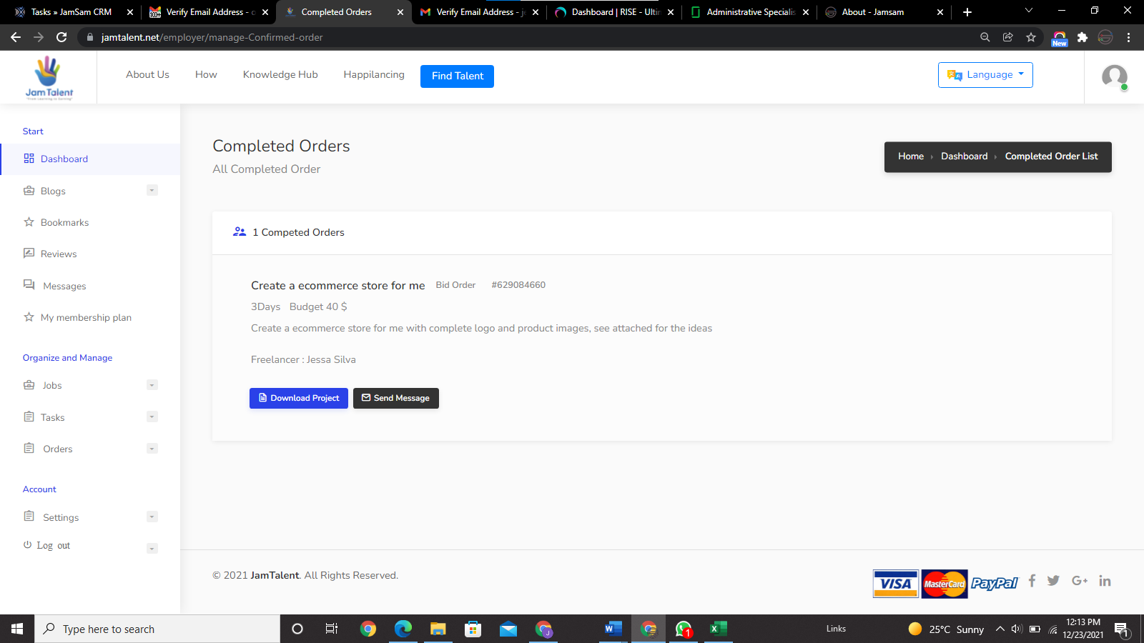 I already rated jessa but there is nothing showing

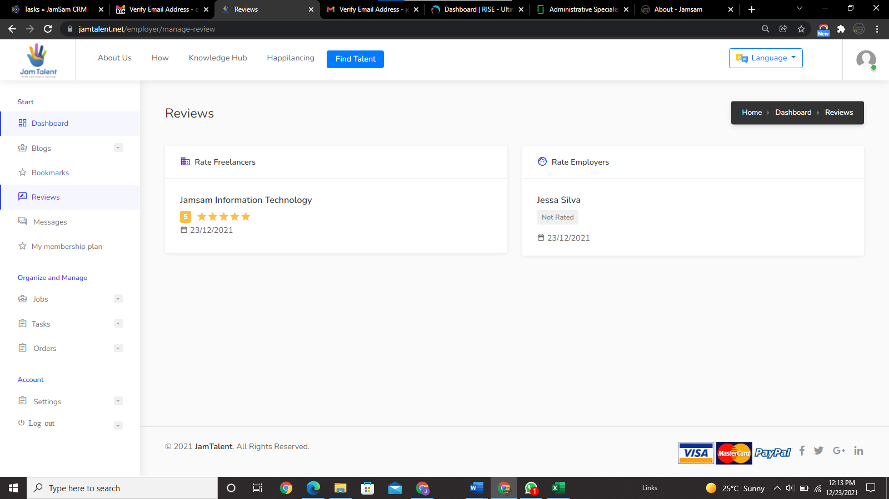here information is wrong, freelancer’s name is on employer, vice versa.